Cardinia Shire Council CCTV

Code of Practice

Contents

1. Introduction 3
2. Statement of purpose 3
3. System description 3
4. Extension of the CCTV system 4
5. Changes to the CCTV system and/or code of practice 4
Minor Changes 4
Major Changes 4
6. Responsibilities 4
7. Accountability 5
8. Public Information 5
9. Assessment of the CCTV system 6
10. Management of Control Room 6
11. Control and operation of cameras 6
12. Recorded material 7
13. Complaints 7
14. Breaches of this code 8
APPENDIX 1 CAMERA LOCATION MAP 1

Introduction

This document details the Code of Practice that will be applied to the management of Cardinia Shire Council’s CCTV system which is monitored by Victoria Police. It acts as a framework for the management and integration of CCTV systems in public places within the Cardinia Shire.

Cardinia Shire Council recognises that fear of crime is an important factor impacting on actual and perceived safety of people within the community. Cardinia Shire Council aims to respond to local safety concerns, adopting a proactive approach to emerging issues identified by residents and visitors.

The installation of CCTV responds to feedback from Victoria Police, local traders, other council partners and our community. The installation of CCTV is part of a suite of crime prevention initiatives including landscape beautification and activation strategies, aimed at reducing crime and anti-social behaviour in the municipality.

Statement of purpose

Cardinia Shire Council and Victoria Police will work together to improve safety, security, address crime and manage anti-social behaviour in Cardinia Shire.

The CCTV system will be used for a combination of passive and active monitoring. Active monitoring will only occur when an incident is occurring and police have sufficient personnel to actively monitor the system.

The system will only be used for the following purposes within this Code of Practice:
- To reduce fear of crime and enhance public perceptions of safety
- To deter and detect crime, criminal damage and public disorder
- To identify, apprehend and prosecute offenders in relation to crime, criminal damage, public disorder, road traffic offences and all forms of harassment
- To provide evidence upon which to take criminal and civil actions in the Courts
- To monitor and assist traffic management issues; and
- to assist other emergency services

System description

The CCTV system consists of 11 CCTV fixed and PTZ cameras focussed on Bourke Park, Pakenham. The Camera Network Monitoring Room is located at the Pakenham Police Station watch house which is staffed by members of Victoria Police. The Camera Network Monitoring Room is not accessible to the public.

A list of camera locations is outlines in Appendix 1.

Cardinia Shire Council is the owner of the CCTV system. Council has ownership and copyright of all recorded information pertaining to the systems. The responsibilities of Cardinia Shire Council in relation to the CCTV system are outlined in Section 6. Victoria Police are partners in the CCTV system and their responsibilities are outlined within this Code of Practice.

Cardinia Shire Council and Victoria Police have entered into a Memorandum of Understanding (MOU) outlining in detail the role and responsibilities of both parties.

Extension of the CCTV system

The current CCTV system design has the capacity to be expanded to other parts of the municipality, if required, and following appropriate consultation.

Changes to the CCTV system and/or code of practice

Minor Changes
A minor change to the CCTV system or the Code of Practice may be made by the designated Cardinia Shire Council responsible officer. A minor change may be required for the purposes of adjustment of the system or clarification of the Code of Practice.

Major Changes
A major change to the CCTV system or the Code of Practice may be made only after consultation and approval from Cardinia Shire Council. A major change is one which will have a significant impact upon the operation of the CCTV System or the Code of Practice.

Responsibilities

Cardinia Shire Council will be responsible for:
- Managing the contract for all installation, servicing, maintenance and replacement of all system equipment
- Ownership of the CCTV system infrastructure excluding ownership of the footage
- Determining CCTV camera locations, in consultation with Victoria Police
- Notifying Victoria Police if it changes the location of any of the CCTV cameras installed
- Scheduled and non-scheduled maintenance costs relating to the CCTV system
- Responding to requests for CCTV maintenance in a timely manner

Victoria Police will be responsible for:
- Owning the CCTV footage
- Day to day management of the CCTV Monitoring system
- Overseeing all monitoring operations
- Ensuring that use of the system by Victoria Police personnel is professional and in accordance with the Victoria Police Manual and Code of Conduct
- Maintaining close liaison with Cardinia Shire Council
- Providing ongoing training to all relevant Victoria Police personnel around the operation of the CCTV system
- Management and storage of Law Enforcement Data
- Release of Law Enforcement Data to statutory prosecuting bodies
- Compliance with the requirements of the Freedom of Information Act 1982 (Vic), and the Privacy and Data Protection Act 2014 (Vic) including but not limited to requests for access and/or amendment to information
- Reporting CCTV system maintenance requests to the Council in a timely manner.

Cardinia Shire Council and Victoria Police are jointly responsible for:
- Overseeing all review, auditing and evaluating processes for the system
- Promoting the system and providing information to the public and other agencies about the operations of the system
- Developing and monitoring all Policies, Protocols and grievance processes in relation to their specific operations and responsibilities

Accountability

Established under the Cardinia Safer Communities Strategic Committee, the Crime Action Group will act as the CCTV Steering Committee. The Crime Action Group meets monthly and will periodically monitor the operation and effectiveness of the CCTV system and identify opportunities for improvement.

Cardinia Shire Council will establish a CCTV Audit Committee to provide public reassurance that the camera system is operated transparently and ethically, and that self-regulatory codes and protocols are being observed.

The CCTV Audit Committee will examine such matters as:
- Complaints received, and responses provided
- Processes used to receive, assess and process access requests
- Whether the systems and processes utilised remain good practice
- Procurement of CCTV

The Cardinia Shire Council CCTV system must comply with all applicable Legislation including the Australian Standard AS 4806 Parts 1-4 Information Privacy Act 2000 and the Freedom of Information Act 1982.

Public Information

Clear and easily accessible information will be available to the community in relation to the CCTV program.

Council will advise the community by installing signage to indicate that they are in an area which has CCTV and that they may be observed or recorded. Signs will be placed at the main entry and exits points to Bourke Park, as well as through the park. The signs will be clearly visible, distinctive and located in areas with good lighting, placed within normal eye range and large enough so that any text can be read easily.

Signs will be prepared so as to be easily understood by members of the public including people from non-English speaking backgrounds. Signs will include a mix of worded text and symbols. The signs will identify Cardinia Shire Council as the operator of the system and information including a phone number will be provided.

Copies of the Code of Practice and information access policies will be made available electronically on Councils website and hard copies made available for viewing to the public upon request.

Inquiries in relation to Cardinia Shire Councils CCTV system and its operation can be made in writing to:

Cardinia Shire Council
PO Box 7
PAKENHAM 3810

Assessment of the CCTV system

Regular monitoring and evaluation of the CCTV system will be undertaken to identify whether the purposes and objectives are being achieved.

The first rigorous evaluation of the CCTV system will occur between 6 – 12 months following the full commissioning of the CCTV system.

Management of Control Room

Only personnel trained and authorised by Victoria Police will operate any of the equipment located within the CCTV control room. Authorised and trained personnel of Victoria Police will be responsible for monitoring and operating the CCTV cameras and will act with the utmost probity. Access to the control room will be restricted and protected from all unauthorised access.

CommSite staff will have access to the control room, with the authority of Victoria Police, to undertake installation, maintenance and testing of the system.

Use of the cameras will accord with the purpose and key objectives of the system and shall be in compliance with the CCTV protocols. Every individual with any responsibilities under the terms of the CCTV protocol’s will be subject to Victoria Police discipline procedures. Any breach of the CCTV protocols or of any aspect of confidentiality will be dealt with in accordance with these procedures.

Control and operation of cameras

Neither Victoria Police nor any of its members will, or are under any obligation to, continually monitor the CCTV system.

The location of cameras will not be hidden to the public and the use of cameras will be in accordance with the CCTV Code of Practice and Protocols.

Cameras will not intentionally be used to look into private dwellings or buildings, unless it is explicitly for the purpose of following (in real time) alleged participants in a crime, which originated in the public domain. Cameras will not be used to impinge on an individual’s reasonable expectation of privacy. Any misuse will be treated as a breach to this code.

“Dummy” cameras will not be used.

Authorised Victoria Police members with authority to access and operate the system will have access to the controls.

CommSite staff will have access to the control room, with the authority of Victoria Police, to undertake installation, maintenance and testing of the system.

Recorded material

The retention of, and access to recorded material will only be for the purposes provided by the Code of Practice and Protocols. Recorded material will be held for a period no longer than 31 days as outlined in the standard operating procedures.
Access to and use of recorded material will only take place:

- In compliance with the needs of Victoria Police in connection with the investigation of a crime;
- If necessary for the purpose of legal proceedings
- When required by a duly authorised subpoena
- As otherwise required or permitted by law

Requests from the public relating to non-criminal matters will be considered by Cardinia Shire Council, who will advise the applicant of Councils Freedom of Information process.
Requests from the public relating to criminal matters will be considered by Victoria Police, who will advise the applicant of the appropriate process.

Recorded material will not be sold or used for commercial purposes or for the provision of entertainment.

The showing of recorded material to the public or the use of the recorded material by the media will only be allowed once approval is given by Victoria Police.

Appropriate security measures will be taken against unauthorised access to, alteration, disclosure, accidental loss or destruction of recorded material.

Recorded material will be treated according to Legislation and Standards, to provide continuity of evidence and to avoid contamination of evidence. Recorded information will be kept on hard drive for a period no longer than 31 days. Footage removed under application may be kept for as long as is required.

All requests for footage must be referred to the Officer in Charge, Pakenham Police Station as appropriate.

Complaints

All matters of public complaint regarding the CCTV system must be referred to Cardinia Shire Council in the first instance for investigation who will decide whether the complaint should be brought to the attention of the Freedom of Information Officer or Victoria Police.

Complaints in relation to any aspect of the management, operation or monitoring of the CCTV system may be made in writing to:

Cardinia Shire Council
PO Box 7
PAKENHAM 3810

Breaches of this code

Cardinia Shire Council has prime responsibility in ensuring that the Code of Practice is adhered to. The responsibility includes ensuring that breaches of the Code are investigated and remedied to the extent that breaches of the Code are within the ambit of Cardinia Shire Councils power to remedy.

All personnel involved with the CCTV system have responsibility to adhere to the Code of Practice.

The Information Privacy Act 2000 authorises the Victorian Privacy Commissioner to receive and investigate complaints about alleged violations of privacy. Any member of the public is entitled to lodge a complaint with Privacy Victoria. Privacy Victoria contact details are as follows:
Privacy Victoria
GPO Box 5057
MELBOURNE 3001

Phone: 1300 666 444
Email: enquiries@privacy.vic.gov.au

Cardinia Shire Council will cooperate with the investigation of any complaint by Privacy Victoria.

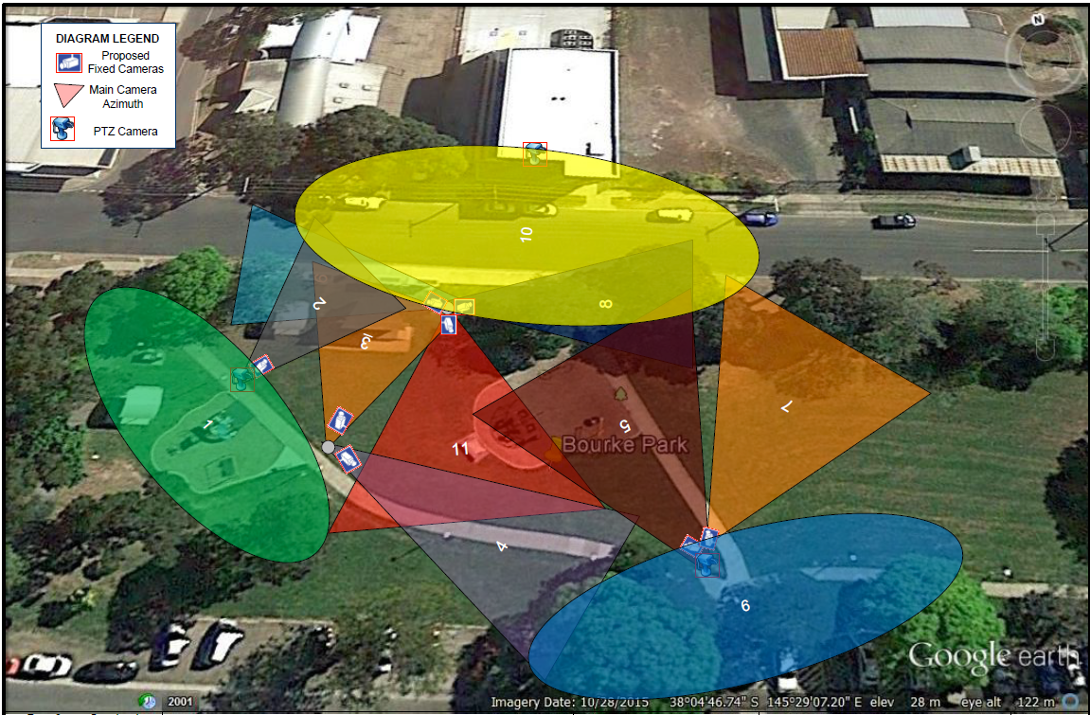
APPENDIX 1 CAMERA LOCATION MAP

