Access and Inclusion

Disability Strategy and Action Plan

2021 – 2026.

Prepared by Emily Tuck and Annmarie Saffin
Cardinia Shire Council
Liveable Communities, Community and Family Services Group
Access and Ageing – Disability.

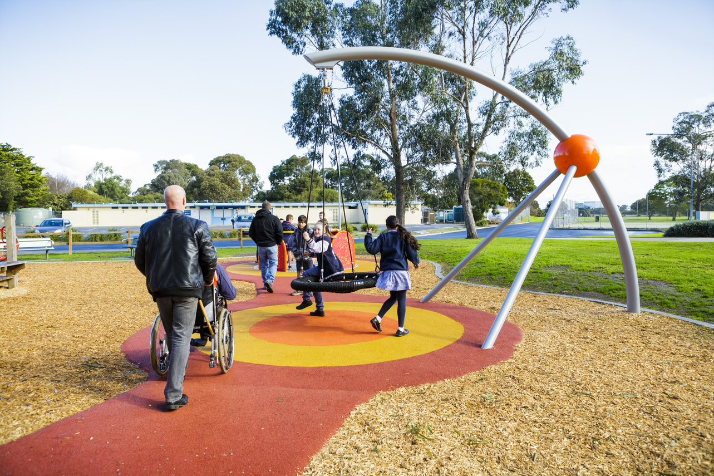

Published December 2021
© Cardinia Shire Council 2021
ABN: 32 210 906 807

20 Siding Avenue, Officer
PO Box 7, Pakenham Vic 3810
(DX 81006)
Phone: 1300 787 624
Email: mail@cardinia.vic.gov.au
Web: cardinia.vic.gov.au

Contents

1. Acknowledgements 2
2. Mayors Forward 2
3. Introduction 3
4. Background 4
4.1 Cardinia Shire Access and Inclusion Advisory Committee 5
5. Our Community 6
6 Population Data - Disability 7
6.1 Demographics 7
6.2 Health 8
6.3 Employment 9
6.4 Education 9
6.5 Safety 10
6.9 Carers 10
6.10 Legislation 10
6.11 Housing 10
6.12 National Disability Insurance Scheme (NDIS) 11
7 Policy Context 12
8 Community Consultation 13
8.1 Covid-19 13
8.2 Methodology to develop the Access and Inclusion Disability Strategy and Action Plan 14
9. Results from Community Engagement 15
9.1 Findings 17
9.1 Public Exhibition of the Draft Access and Inclusion Disability Strategy and Action Plan 2021-2026 17
10. Action Plan 18
11. Implementation 19
12. Appendix 1 20
13. Appendix 2. 23

Acknowledgements
Cardinia Shire Council respectfully acknowledge that we are on the traditional land of the Bunurong, Boonwurrung and Wurundjeri people. We value their contributions past, present and future.

Council appreciates the invaluable contribution from our residents, Councillors, community organisations, service providers, and Council officers who shared their vision, knowledge and experiences during the consultation process and development of this plan.
Council expresses gratitude to the Cardinia Access and Inclusion Committee; The Access and Inclusion Committee Members have been integral in the development of the Action and Inclusion Disability Strategy and Action Plan 2021-2026.

We strive to create a Cardinia Shire where residents can actively participate in their community, regardless of their ability. A community that enables and encourages people, where everyone is valued.

Mayors Forward

I am proud to present Cardinia Shire Council’s Disability Action Plan 2021–26.

In this key strategy and action plan, we set out what Council will do to make our community, services, programs, and workplace more accessible to people with disability.

Our Access and Inclusion Disability Strategy and Action Plan 2021–26 builds on our learnings from our previous disability action plan and is based on 4 key principles:

- reducing barriers to people with a disability in accessing goods, services, and facilities
- reducing barriers to people with a disability in obtaining and maintaining employment
- promoting inclusion and participation of people with a disability in the community, and
- achieving tangible changes in attitudes and practices that discriminate against people with
disability.

On behalf of Cardinia Shire Council, I take this opportunity to acknowledge members of the Cardinia Access and Inclusion Advisory Committee for their ongoing commitment and insight. Members of the committee have been integral in the development of this plan, and we thank them for all that they do in helping to make our shire more welcoming, inclusive, and accessible for all.

I also thank the community members, disability sector service providers, advocates and organisations that provided valuable input into the development of this plan as part of the extensive community consultation process.

I am proud that this strategy and action plan reflects the needs and aspirations of our vibrant and diverse community, and that it will guide our important work in this space over the next 5 years.

Cr Jeff Springfield
Cardinia Shire Mayor 2021–22

Introduction
The Access and Inclusion, Disability Strategy and Action Plan, 2021-2026 builds on our commitment to fostering an inclusive, equitable and safe community for all. It follows on from the 2017/2021 Disability Action Plan which had 30 action items that were achieved. This plan builds upon the learnings of the previous plan and is underpinned by the Cardinia Shire values of teamwork, respect, accountability, communication, and customer focus along with our culture statement of together, different, future.

Cardinia Shire is an inclusive organisation valuing our community for its unique qualities, ideas, and insights. Cardinia Shire acknowledges our community as one that is diverse in age, culture, life experience, gender identity, race, ethnicity, disability, faith, sexual orientation, or other diversities. The Access and Inclusion Disability Strategy and Action Plan mirror this value in recognising that people with disability also experience diversity in various ways.

The Access and Inclusion, Disability Strategy and Strategy and Action Plan, 2021-2026 has been developed in the context of fundamental change in disability policy and sector. The National Disability Insurance Scheme Act was legislated in 2013, and subsequent rollout to the Southern Melbourne Area incorporating Cardinia Shire occurred in September 2018. A new national disability strategy is in development and the Royal Commission into Violence, Abuse, Neglect and Exploitation of People with Disability commenced in 2019 and is ongoing. In Victoria consultation is underway for the next state disability action plan 2021-2024. It is also important to recognise the impact of the Bunyip bushfires in March 2019 and the unprecedented challenges presented by the Coronavirus pandemic. These events highlight the importance of considering the needs of people with disability and ensuring inclusion in emergency planning and recovery.

This document outlines Council’s commitment to people with disability having full equity, inclusion, and participation rights as they live, work, learn and explore Cardinia Shire. It reflects the changing policy environment and builds upon current and emerging opportunities to be an accessible and inclusive community.

Most importantly “Nothing about us without us ” is a key ideology of the disability community. This strategy and action plan is developed with input by Cardinia Shire’s disability community, support and services sector, advocacy groups, community committees, educators, carers, and families.

Background
Cardinia Shire Council has both ethical and statutory responsibilities to ensure that all people have equal access to services, facilities, and resources within the community. Section 38 of the Victorian Disability Act 2006 states that councils are required to prepare a disability action plan that identifies actions to remove barriers for people with a disability. It is designed to promote inclusion and participation of people with disability and change attitudes and practices which directly or indirectly discriminate against people with a disability.

Disability is described by the World Health Organisation as "an umbrella term, covering impairments, activity limitations, and participation restrictions”. An impairment is a problem in body function or structure. Some people are born with a disability, many acquire a disability because of an accident, illness, genetic condition or as part of the aging process. A disability may be visible or hidden, permanent or temporary and have minimal or substantial impact on a person’s abilities.

Along with different disability ‘types’ it is also acknowledged that disability may be experienced alongside other barriers to participation such as age, culture, life experience, gender identity, race, ethnicity, disability, age, faith, sexual orientation, or other diversities.

People with disability are part of every segment of our community: women, men, and children; employers and employees; students and teachers; Indigenous and non-Indigenous; customers; refugees and citizens. No two people with the same disability experience their disability in the same way. The only thing that distinguishes a person with disability is they may require some form of adaptation/adjustment to enable them to do certain things in the same way as people without a disability. This achieves equity.

The Southern Melbourne Area is forecasted to experience the largest growth in the number of people receiving National Disability Insurance Scheme (NDIS) support and concurrently the Southern Melbourne Area will require the largest increase in workforce.

Locally disability reform included rescinding the Metro-Access role and scope of works. Council responded to this with ongoing commitment to resourcing the disability portfolio.

People with disability have a wide range of conditions and impairments. What they have in common is a shared experience of encountering negative attitudes and barriers to full participation in everyday life. The ‘social model of disability’ is based on the understanding that disability is caused by the barriers to participation in community life or that disability is socially constructed, rather than by a person’s own impairment. The social model places the person at the forefront and highlights that it is the environment and/or negative attitudes that are most ‘disabling’ to individuals living with an impairment. It emphasises dignity, independence, choice, and privacy. When the environment and opportunities are presented in a more accessible and inclusive way, people can be enabled to achieve their best. The social model does not deny the experience or impact of disability. It challenges the physical, and social environments, our attitudes, the way we communicate and socialise to accommodate disability and an expected occurrence of diversity. This is the impetus for having a strong Access and Inclusion Disability Strategy and Action Plan.

Cardinia Shire Access and Inclusion Advisory Committee
In 2005, Cardinia Shire established the Access and Inclusion Advisory Committee (formerly The Cardinia Disability Advisory Committee). The Committee was established to provide a forum for Cardinia Shire residents, businesses, and community groups, representing the interests of people with disability in the Local Government Area. The objectives of the committee are to:

- Monitor, review, and support Council’s disability policy,
- Provide information and advice to Council on issues impacting upon people with a disability,
- Participate in strategic planning, and
- Act as ambassadors for the disability community.
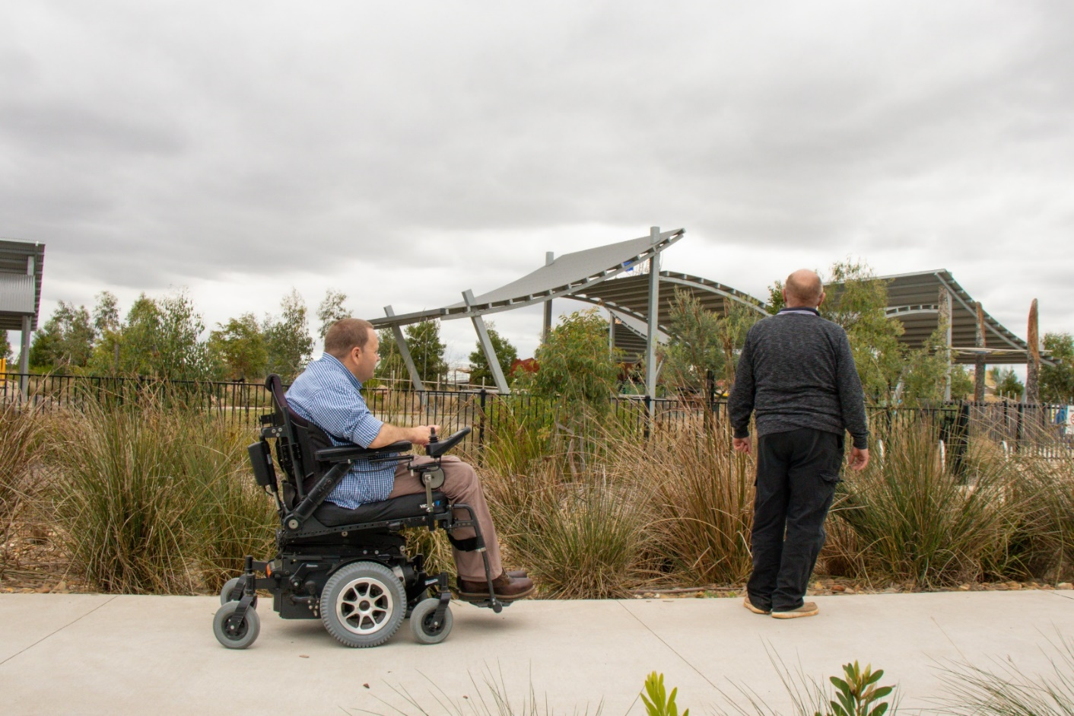
Figure 1 Image of Cardinia Access and Inclusion Committee Members at Deep Creek Reserve, Pakenham

Our Community
Cardinia Shire is in the south east of Melbourne, about 55 kilometres from the Melbourne CBD and is where land use transitions from urban rural. Cardinia Shire has an area of 1,281 square kilometres.

Cardinia Shire has diversity of landforms and landscapes. It is bound by the hills of the Yarra Ranges to the north, and Westernport Bay to the south and continues the growth corridor from the City of Casey. It is an area of rapid growth in population and concurrent development.

The 2021 estimated population of Cardinia Shire is 126,184 people. Over the next 15 years we expect this to increase by 43 per cent to a total of 180,308 people in 2036. Most of the Cardinia Shire’s population is located within the growth areas of Beaconsfield, Officer and Pakenham, which will also accommodate the majority of future residential and commercial growth . It is forecasted that Cardinia will experience significant population growth over the next twenty years. Reflecting this trend will be a corresponding increase in the number of our residents living with a disability.

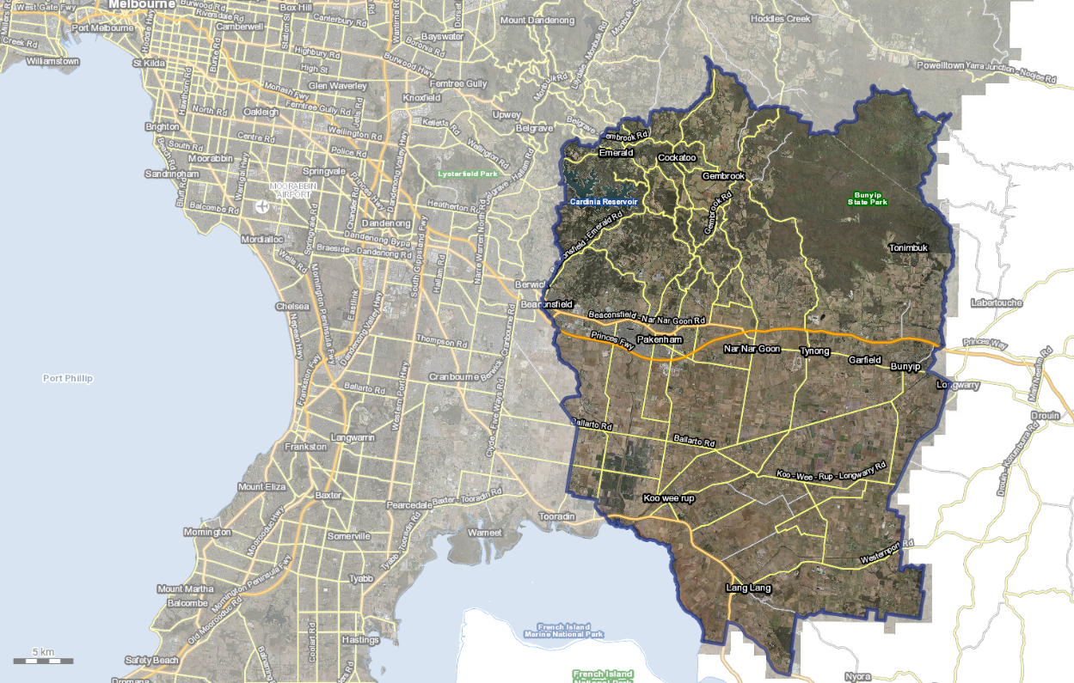
Figure 2 Cardinia Shire aerial map. Source Near Maps, 2020

Population Data - Disability

Demographics
The disability population is diverse. It encompasses people with various types of disability across all age groups, socioeconomic and demographic groups. The experience of disability is also diverse, people with the same disability do not experience their disability in the same way.

There are 4.4 million people who have disability in Australia. That is, 1 in 6 people. 5.7% of the Australian population experience profound or severe disability. This means sometimes or always needing help with daily self-care, mobility, or communication activities.

In 2019, Cardinia Shire was home to almost 4,000 residents who have disability. Figure 3 Disability statistics is a summary of disability statistics in Australia.

Figure 3 Disability statistics
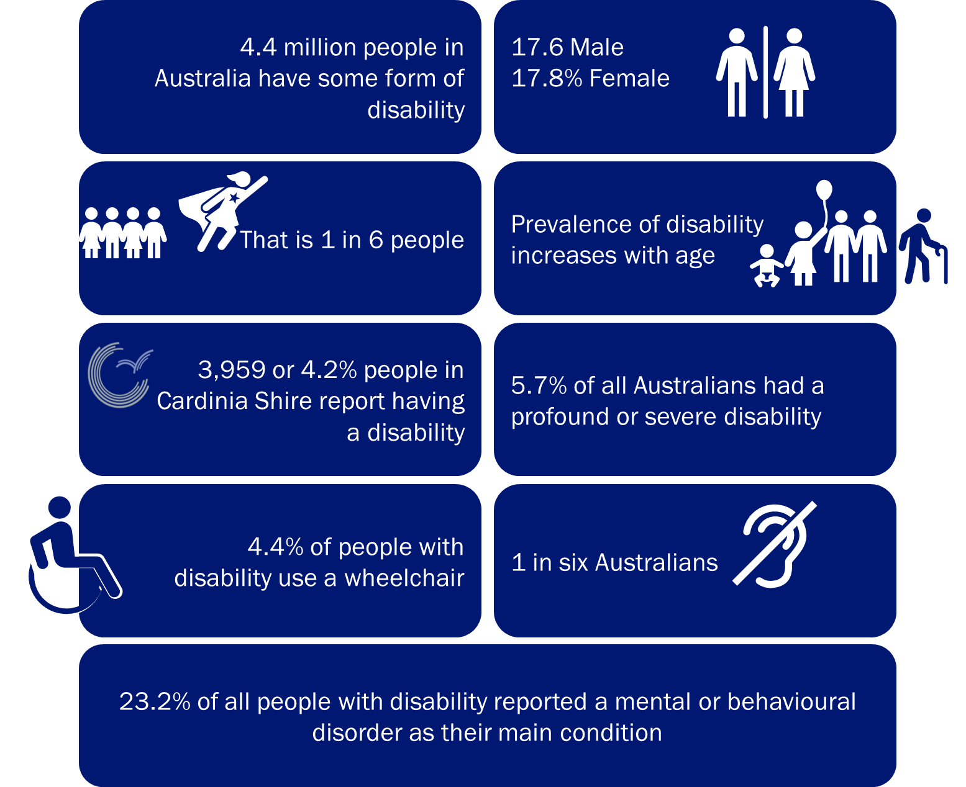

The Australian population is getting older, and disability prevalence increases with age. People over 65 years account for 50% of people who have a disability. In 2030, Cardinia Shire is forecasted to have 8,404 residents with a disability an increase of 82%. More than 5,048 or 60% of all Cardinia Shire residents with disability will be above 65 years (Figure 4).

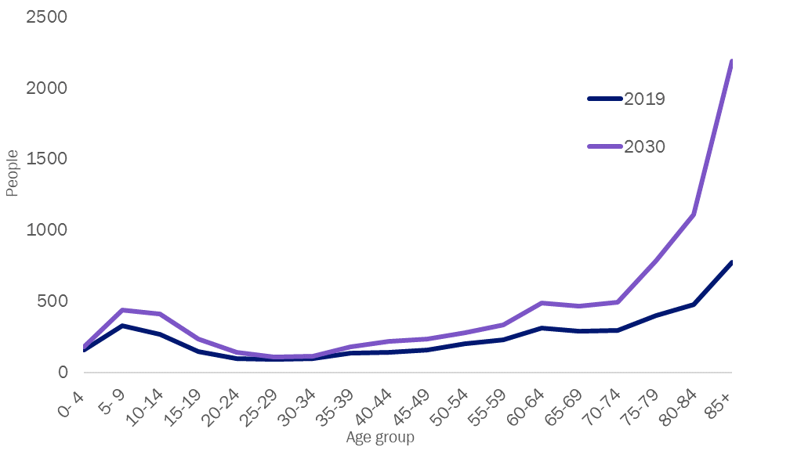
Figure 4 Cardinia Shire prevalence of disability by age group, comparison 2019 – 2030
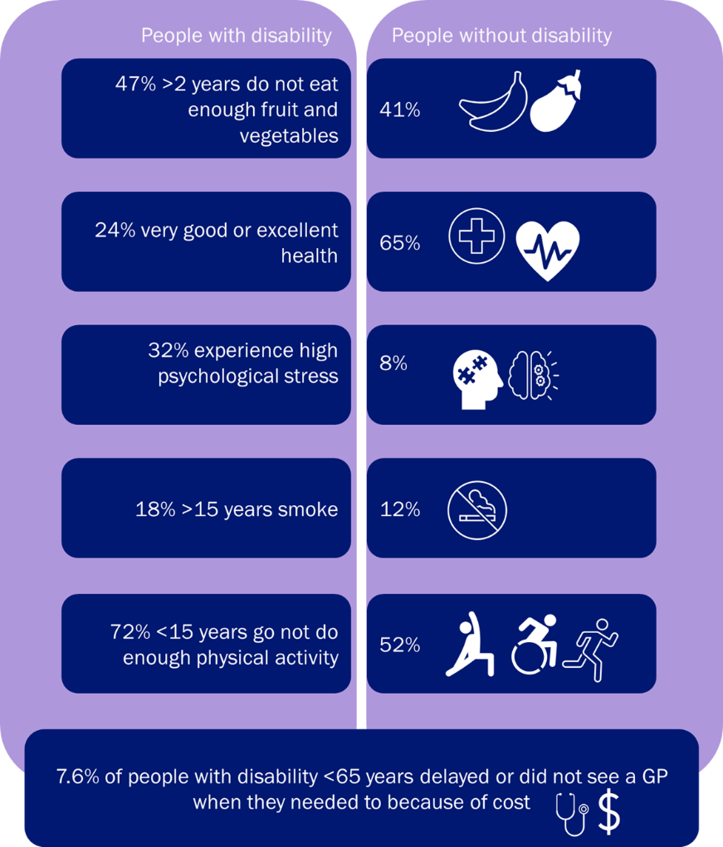

Health
Figure 5 Health disparity statistics for people with disability
The relationship between health and disability is complex. Long term health conditions can lead to disability, and disability can contribute to health problems. The nature and type of disability can influence health states, disability can lead to limited access to and participation in social and physical activities.

People with disability report poorer general health and higher levels of stress than people without disability, they also have higher rates of modifiable risk factors such as poor diets, smoking, less exercise, and experience barriers to accessing health services. Figure 5 provides a summary of health disparity between people with and without disability

Employment
People with disability face challenges seeking and engaging employment. Paid work builds self-worth and independence. The unemployment for people with disability is double (10%) when compared to people without disability (5%). People with disability are often underemployed and would like to work more hours. Underemployment means earing less and exclusion from opportunities to participate in the community.

Cardinia Shire Council has a role to ensure our recruitment practices are inclusive, ensuring our vacancies reach people with disability and disability employment agencies and that our reasonable adjustment policies are current.

Council also has a role in promoting disability awareness training to build capacity within our business community to engage with people with disability and disability employment agencies.

Education
Education is about attaining knowledge and life skills to participate in day to day lining. Having a higher level of education attainment is associated with greater employment outcomes, higher income and self-worth, security, and independence. Figure 6 provides statistical information about disability and the education system.

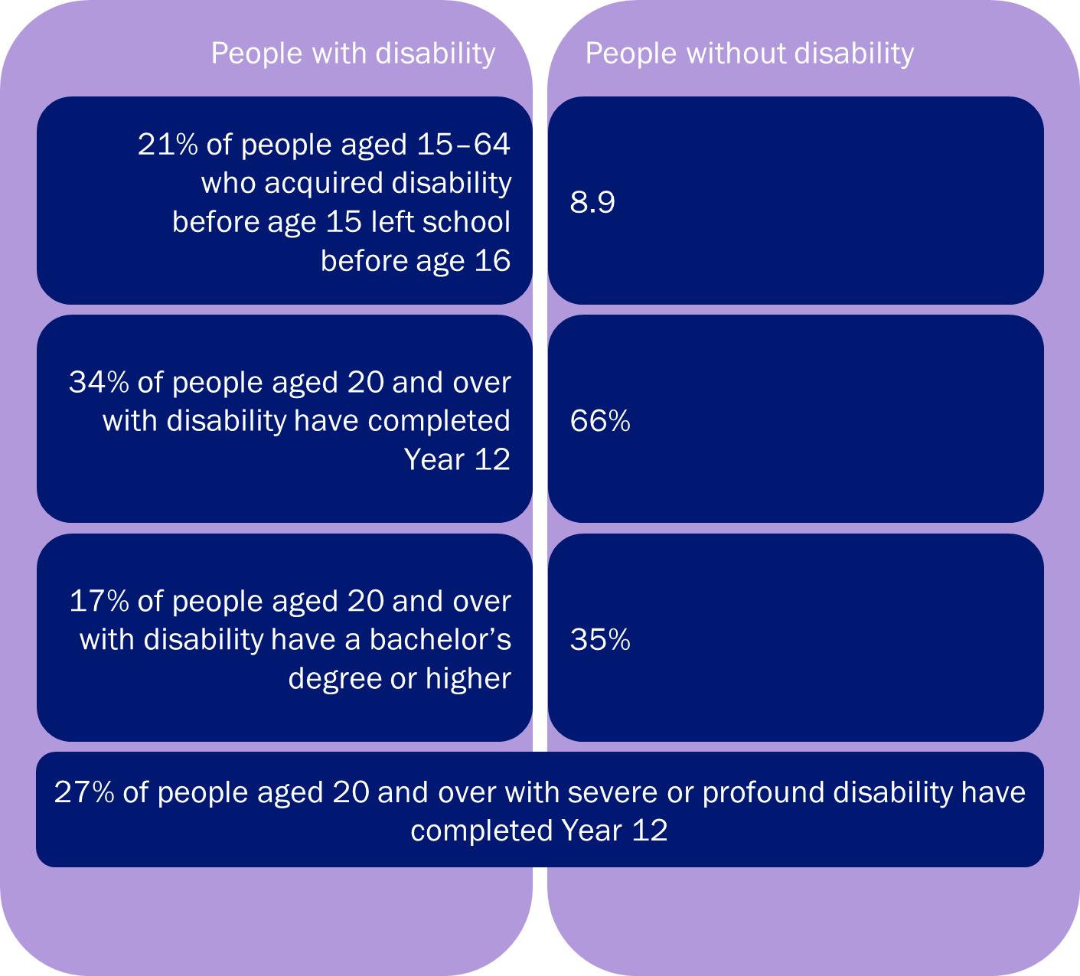
Figure 6 Education statistics

Safety
People with disability can experience higher rates violence, abuse, neglect, and exploitation than people without disability. Along with this they can also encounter barriers to expressing their experiences and asserting their rights. The Royal Commission into Violence, Abuse, Neglect and Exploitation of People with Disability commenced in 2019 and is ongoing. In Cardinia Shire there are an average 4 reports of family violence each day .

Disability discrimination occurs when a person with disability is treated unequally, less favourably, or not given the same opportunities as other people because of their disability. This can be direct for example refusing entry to a playground because they have an assistance dog or indirect where steps preclude entry to a person using a wheelchair. The Disability Discrimination Act 1992 makes it unlawful to discriminate or to treat people unfairly because of their disability.

Carers
Carers are people who provide unpaid care and support to people who have a disability, health conditions and or older people. Carers are essential to support our disability community to support with day to day activity and personal care. They also manage any administration and connect to the broader health, emotional and social supports.

There are over 2.65 million carers in Australia, around 240,000 carers in Victoria. In 2016, Cardinia Shire was home to 8,146 residents who provide care or assistance to a person with disability, long term illness or old age. The average age of a primary carer is 54 . Approximately 45% of carers care for their partner, 24% for their children with care needs, 21% for their parents and 10% for a relative or friend.

Legislation
Cardinia Shire Council is required under section 38 of the Victorian Disability Act 2006 to develop a Disability Action Plan. Council must report on the implementation of the Disability Action Plan in its annual report under section 98 of the Local Government Act 2020 .

The Access and Inclusion Disability Strategy and Action Plan sets out the steps that Cardinia Shire Council will take to make the products and services we deliver to the public more accessible and inclusive, as well as outlining the steps Council takes to make our corporate culture and practices more inclusive.
The Access and Inclusion Disability Strategy and Action Plan is prepared for the purpose of:
- reducing barriers to persons with a disability accessing goods, services, and facilities.
- reducing barriers to persons with a disability obtaining and maintaining employment.
- promoting inclusion and participation in the community of persons with a disability.
- achieving tangible changes in attitudes and practices which discriminate against persons with a disability .

Housing
Council recognises affordable housing as a human right and an important link to a liveable neighbourhood; critical to creating a ‘liveable, resilient community where the environment flourishes and residents are healthy, included and connected’.

A variety of hidden ongoing living costs, particularly transport costs associated with lower residential densities and limited public transport access introduce further affordability issues, with many residents living in greenfield sites at risk of mortgage and rental stress should petrol prices rise. This can be an issue for people with disability, whose households can face other disadvantage in the private market that makes accessing appropriate housing challenging.

Financial vulnerability and housing insecurity can be exacerbated by chronic health, disability, and family violence. Figure 7 below outlines housing statistics for people with disability.

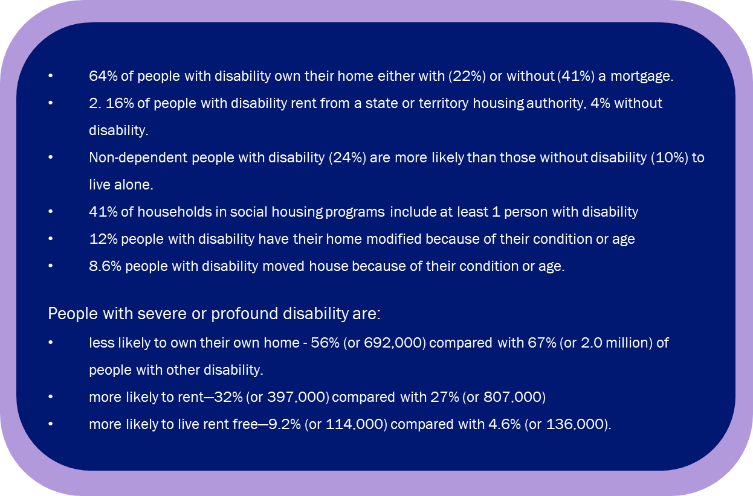
Figure 7 Housing statistics in relation to disability

National Disability Insurance Scheme (NDIS)
Cardinia Shire entered the NDIS in November 2018. The NDIS changed the way people with disability receive and use disability support services. The NDIS gives the funding directly to people with disability who meet the NDIS access requirements of permanent and significant disability. It is designed to get the support people with disability need to improve their skills and independence over time.

For people with disability who do not reach NDIS access, the NDIS provides information and connections to community services. This includes connections to doctors, sport clubs, community social groups, libraries, and schools.

The diagram in Figure 8 summaries the Australian population with disability. There are 25 million Australian’s, 4.4 million Australians have a disability. The NDIS is expected to fund around 500,000 people in Australia to receive the NDIS support they need to improve their skills and independence over time. 11.3% of Australians with a disability receive funded NDIS supports. In Cardinia Shire 37% of residents with disability received the funded NDIS supports. The remaining 63% are supported through the information and connections (informal supports) and mainstream services (formal supports) such as education, healthcare, justice system and others. Because there is a higher proportion of Cardinia Shire residents with disability as NDIS participants it can be inferred that there is a higher proportion of people with a more significant and profound disability in Cardinia Shire.

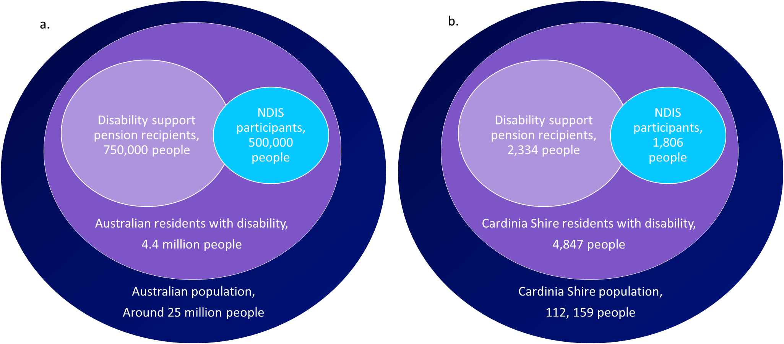
Figure 8 NDIS funded support a) Australia, b) Cardinia Shire (2019)

Policy Context
Disability action plans are an important local government resources to reduce barriers, promote inclusion and participation and change attitudes and practices.

Cardinia Shire’s Access and Inclusion Disability Strategy and Action Plan is informed externally by international, national, and state-wide strategies and legislation (Figure 9). Internally, strategies and plans that have informed the access and inclusion disability strategy and action plan include the Council Plan, the Liveability Plan, and the Social Justice and Equity Plan (Figure 9).

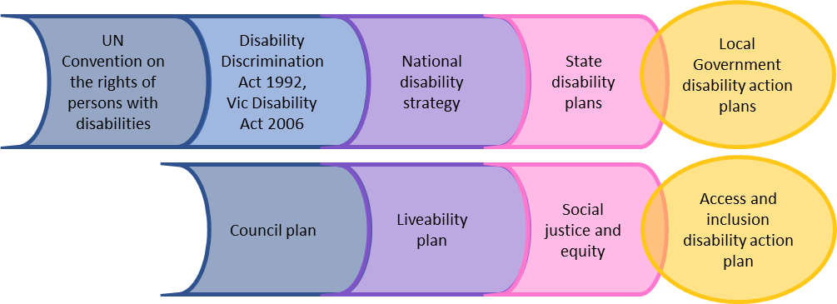
Figure 9 Legislation and strategies informing Cardinia Shire’s Access and Inclusion Disability Strategy and Action Plan.
The social justice and equity plan provide a framework to uphold the human rights of our diverse communities and promote the social justice principles of participation, access, and equity in all aspects of community life. It unifies and is supported by a suite of actions that focus on specific areas of diversity including:
- Disability
- Reconciliation
- Cultural diversity, and
- LGBTIQ+
The Council Plan 2021-2025 outlines the priorities and steps required to deliver the long-term vision, which is:

“The unique identity of our urban, hills and rural areas is strengthened. We meet the challenges we face together as a community. How we respond balances the needs of our people, businesses, our productive land and natural environments.”

The Council Plan correlates with Council’s Liveability Plan (Cardinia Shire’s Municipal Public Health and Wellbeing Plan), a legislative requirement under the Victorian Public Health and Wellbeing Act 2008 and the Disability Strategy and Action Plan (Refer to Figure 10). The Access and Inclusion Disability Strategy and Action Plan leverages from these two Plans and overlays, the particular challenges people with disability encounter as they navigate their way through community life.

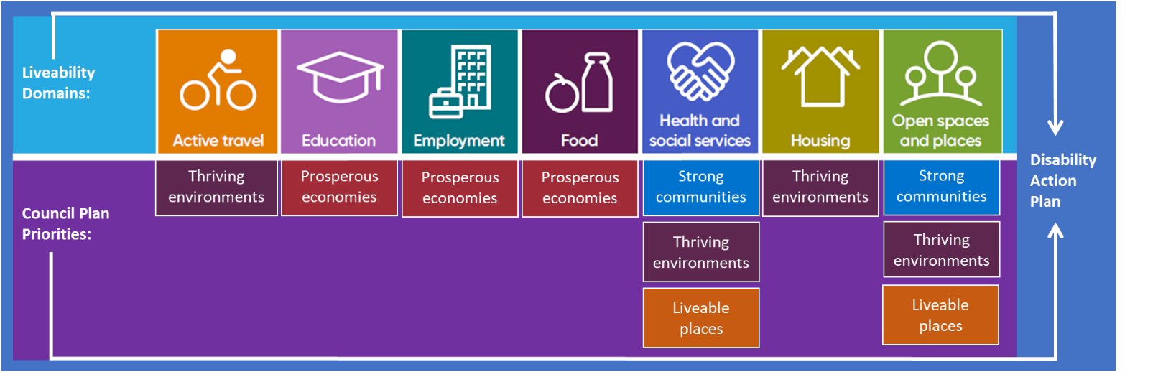
Figure 10 Liveability Plan overlayed with Councils priorities and link to Disability Strategy and Action Plan

Community Consultation

COVID-19
COVID-19 has deeply impacted communities around the world. Victoria has had additional challenges imposed by the restrictions in relation to coronavirus. The impact of coronavirus delayed consultation for key Disability Strategies:

- National Disability Strategy
- State Disability Plan
- Review of the Victorian Disability Act 2006
The pandemic has impacted on the timing of community consultation and engagement for the Access and Inclusion Disability Strategy and Action Plan 2021-2026.

Methodology to develop the Access and Inclusion Disability Strategy and Action Plan
The Access and Imclusion Disability Strategy and Action Plan was informed by our community and Council. It sets out what we will do to make our workplace, services, programs and community more accessible to people with disability, to ensure they are equitable, inclusive, and safe.

A range of engagment activities focused on the Australian Institute of Health and Welfare person-centred framework where the the person is central to the surrounding determinants that influence their health and wellbeing. The determinants explored in the engagement activities included education and employment, access and inclusion, and, discrimination.

The engagement opportunities on the new Acceess and Inclusion Disability Strategy and Action Plan included:
- Face to face pop up sessions across the shire:
  - Pakenham
  - Koo Wee Rup
  - Deep Creek Reserve
  - Emerald
- Creating Cardinia Web Page, outlining the opptortunities to provite feedback and the strategy and action plan development timeline
- 2 online sessions
- Online survey
- Online activity
- Paper surveys
- Face to face sessions at local promary schools
- Internal staff workshop
- Internal Councillor workshop
The concurrent communications about the engament opportunities included:
- Social media posts
- Social media events
- Paid social media advertising
- News paper print advertising
- Emails to disabily comminity sector and community
- Officer specialist school newletter post, 300+ readership
- Mayor of the air radio promotion on ABC Gippsland
- Internal business feed posts
- Business feed calendar entries for events
- Emails to all staff
- Councillor bulleting
- CEO newletters

Results from Community Engagement
The community engagement activities resulted in a total of 655 comments and suggestions. A breakdown of the engagement activities and feedback items is in Table 1 below. 34% of survey respondents identify as having a disability, 17% identified as a parent or guardian of a person with disability (for more results on survey respondent demographics, refer to Appendix 1, page 20 ).
“People ignore me all the time in the retail / hospitality industry. They'll talk to the person I’m with rather than me.”

Table 1 Community engagement summary, number of comments.

Engagement activity | Access to good spaces and places | Inclusion and participation | Employment and education | Prevent discrimination | Totals
Survey | 137 | 82 | 112 | 53 | 384
Access and Inclusion Committee | 10 | 12 | 5 | 7 | 34
Councillor workshop | 8 | 7 | 5 | 6 | 26
Council staff workshop | 26 | 12 | 15 | 9 | 62
Primary school engagement | 30 | 21 | 1 | 0 | 52
Sector consultation | 11 | 13 | 10 | 3 | 37
Pop up sessions | 32 | 18 | 6 | 4 | 60
Total | 254 | 165 | 154 | 82 | 655

Below are some of the comments from the community, and council engagement:
“more accessible car parks with good access to footpaths.”

“I have a high level of intelligence. I use a walker. Apparently, for some people, this equates with stupidity. Not mine, I assure you.”

“supporting carers and family to feel comfortable in public places and removing the shame of disability.”
“People with disability should be included in all our flyers, website etc.”

“remove physical barriers for accessing all community facilities.”

“we should support more people with disability to work at council.”

“mentor program for people with disability.”

Children submitted images about how we can improve access and inclusion for people with disability, below (Figure 11 Images gathered from children’s community consultation/engagement. includes examples of the children’s drawings and a engagement activity.

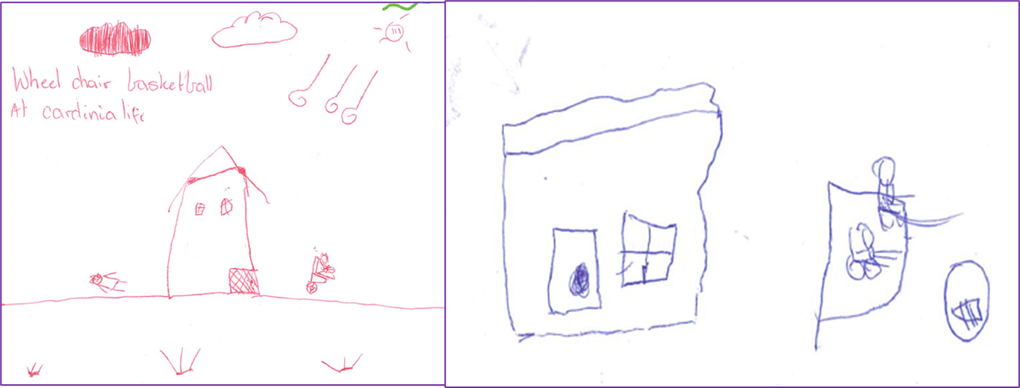
Figure 11 Images gathered from children’s community consultation/engagement.

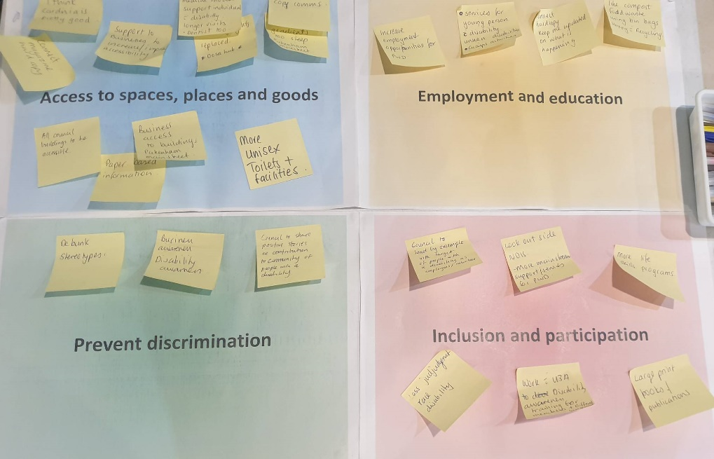
Figure 12 Image of a community engagement pop up session.

Findings
A thematic analysis of the comments and suggestions was undertaken, and three strong themes evolved:
- Liveable places: create accessible spaces and places
- Strong communities: an inclusive culture reflecting our diversity
- Independence: Living working and learning locally.

An element that is embedded in all three themes is preventing discrimination. By responding to the three themes council will also be responding to discrimination by creating accessible places, changing attitudes, celebrating diversity, communicating effectively, creating employment and housing options.

These themes represent the voice of the community and link to both our legislative requirements and our Council and Liveability Plans.

Figure 13 Results: emerging themes below is a visual representation of the themes and the common element of preventing discrimination:

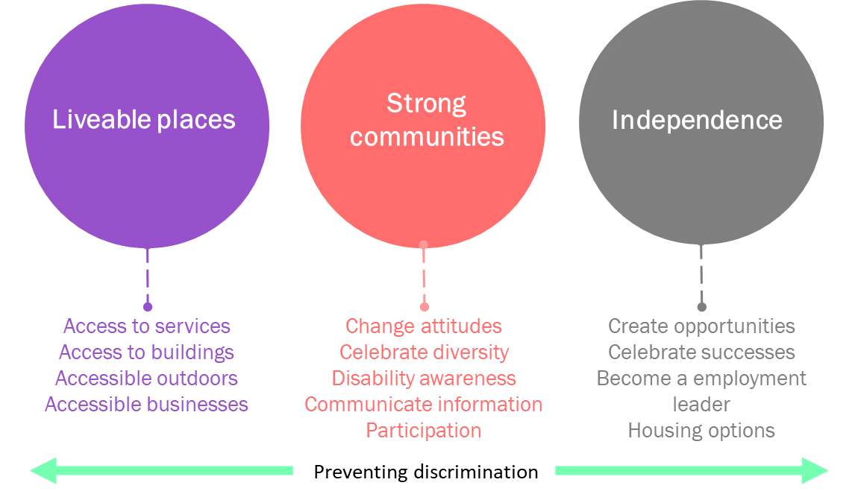
Figure 13 Results: emerging themes.

Public Exhibition of the Draft Access and Inclusion Disability Strategy and Action Plan 2021-2026
The draft Access and Inclusion Disability Strategy and Action Plan was available for public exhibition on our engagement platform for four weeks. The community was asked if Council has understood their contribution to the Plan, and if the action plan responds to the goal of improved access and inclusion for people with disability in Cardinia Shire. The draft was translated and presented in an easy read format extending the accessibility of information to all user groups.

An invitation to provide feedback on the draft Access and Inclusion Disability Strategy and Action Plan was shared on Cardinia Shire’s corporate social media platforms, and in local newspaper print advertisements.

The Creating Cardinia draft Access and Inclusion Disability Strategy and Action Plan engagement opportunity resulted in 183 views, 149 visits and two written contributions. One contribution related to access issues at a specific venue and not on the content of the Access and Inclusion Disability Strategy and Action Plan, this has been forwarded to the respective business unit for follow up. The second contribution was reiterating the importance of increasing the visibility of people with disability in our media and communications which has been captured in the Action Plan. Of the two contributions none of them participated in any of the original engagement activities therefore are unable to comment on the validity of the themes in the Access and Inclusion Disability Strategy and Action Plan generated from the original engagement activities.

As a result of the public exhibition, no feedback was received about the content of the draft Access and Inclusion Disability Strategy and Action Plan, therefore no changes have been made to the document.

Action Plan
The Access and Inclusion Disability Strategy and Action Plan sets out the steps that Cardinia Shire Council will take to make the products and services we deliver to the community more accessible and inclusive, as well as outlining the steps Council takes to make our corporate culture and practices more inclusive.

The Access and Inclusion Disability Strategy and Action Plan responds to the themes identified in the consultation and Council’s legislative requirements under the Victorian Disability Act 2006.

The following table outlines Council’s priority areas and objectives of the Access and Inclusion Disability Strategy and Action Plan 2021-2026. An operational Disability Action Plan detailing 51 items, timeframes, and responsibilities to deliver the action plan is included in Appendix 2.

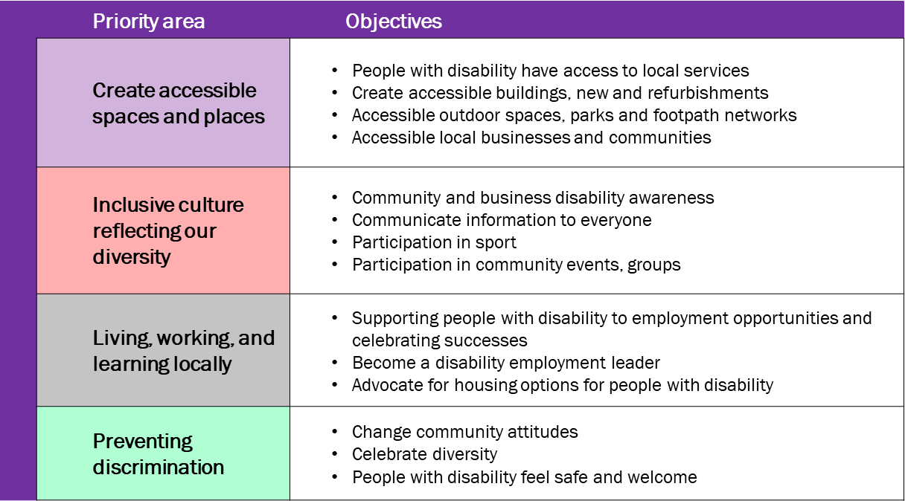

Implementation
Within the Community and Family Services Group, the Access and Ageing team is responsible for monitoring the implementation and reporting of the Access and Inclusion Disability Strategy and Action Plan.

Each action item is owned by a Cardinia Shire group. The group is responsible for delivering the action item within the allocated timeframe.

To meet Council’s legislative requirements, the Access and Inclusion Disability Strategy and Action Plan progress will be reported in the Cardinia Shire Council’s annual report.

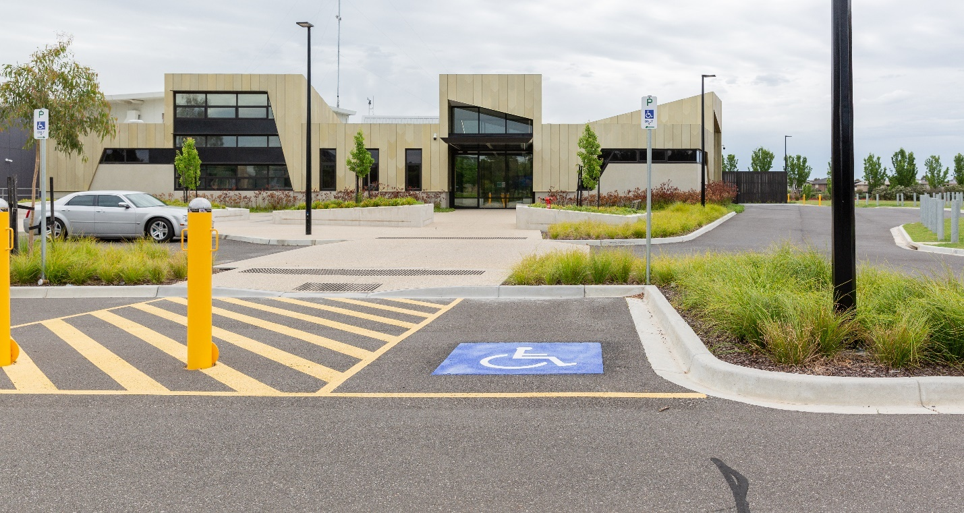

Appendix 1

Community engagement – participant details
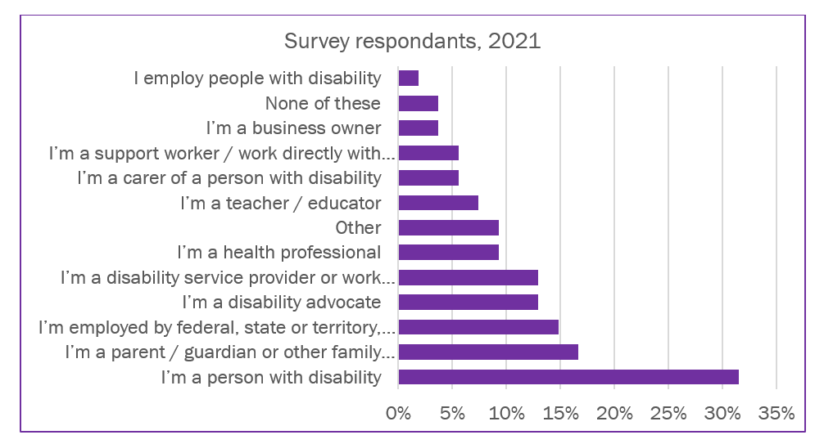
Figure 14 Survey demographics

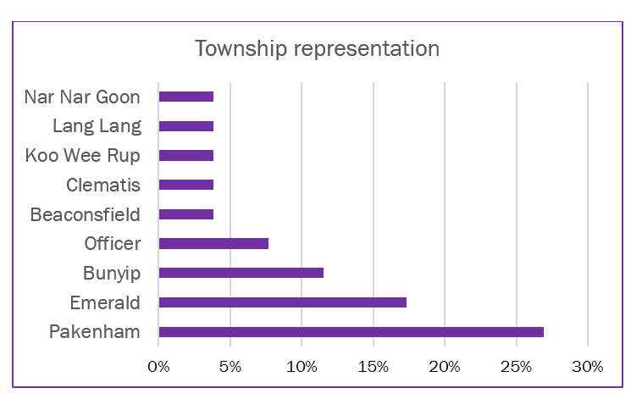
Figure 15 Township representation

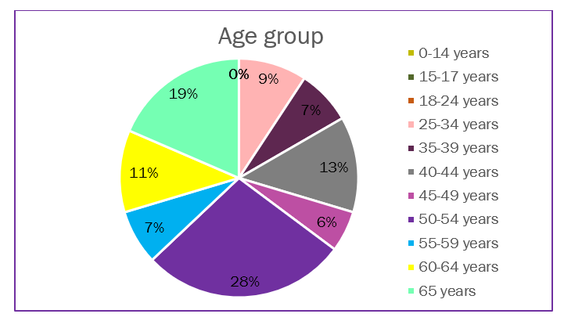
Figure 16 Age group of survey participants

Appendix 2.

Action Plan 2021-2026
Item no. | Action | Outcome measure | Time- frame | Lead Group | Partner
Priority area 1: Create accessible spaces and places
1.00 | Re-activate and update good Access is Good Business. | Updated Good Access is Good Business resources | 2021-2023 | Governance facilities and economy | Access and ageing
1.01 | Guest speaker to attend business group meetings to increase the business sector’s awareness of disability matters (as an employer and goods and service provider). | Annual presentation from disability sector attended by minimum of 20 members | 2023-  2025 | Governance facilities and economy | Cardinia business group
1.02 | Advocate for support for young people with disability for Home and Community Care Program for Young People (HACC-PYP) | Include service gaps and opportunities in quarterly reports to State Government | 2024 | Liveable communities | DFFH, MECWA Care
1.03 | Provide more spaces for providers to see clients with Disability in council facilities (services for success)  Attract disability services providers and therapists to Cardinia Shire | Services for success reporting framework, also measured in the Liveability Plan Framework | 2024 | Liveable communities | Future Communities  Services for success
1.04 | Build staff awareness and understanding of the Carers Recognition Act 2012. Develop a staff awareness package about the Act principles and charter. | Information available to staff on iLearn and in the enterprise bargaining agreement, reported in Council’s annual general report | 2023 | Customer people performance | Learning and development
1.05 | Annual review of footpath register to identify access issues that can be remediated under the Access Upgrade Program. | Annual review complete, one access upgrade completed per year | Annual | Infrastructure services | Access Upgrade Program
1.06 | Develop township maps identifying all accessible parking spaces, uploaded to Cardinia Community Compass | 2 maps per year completed and available on Cardinia Community Compass | Annual | Infrastructure services | Information Services
1.07 | Audit of number of accessible parking permits across the shire, by postcode over the last 5 years | Report completed; report used to inform the distribution of accessible parking bays across the Shire. | 2022 | Customer people performance  Infrastructure services | Access and Ageing
1.08 | Increase community understanding of compliance enforcement in the areas of accessible parking bays, parking time limits, parking permits and crossovers. | External communication about the benefits of parking and crossover compliance through Council’s communication channels eg. Connect, social media. | 2023 | Regulatory services | Access and ageing  Communications
1.09 | Update webpage of Power Up locations in the shire | Website information of Power Up resources accessible to community members updated annually | 2023 - 2026 | Liveable communities | Access and ageing
1.10 | Host an annual Universal Design training event for Council staff and Councillors | Delivery of the training event to minimum of five staff, increasing their knowledge of universal design to apply within their Council role | 2023 - 2026 | Customer people performance | Access and ageing
1.11 | Establish a working group to develop a policy on universal design for Council assets and open spaces | A Council policy on implementation of Universal design principles is developed and implemented. | 2023-2024 | Liveable communities | Governance facilities and economy, infrastructure and environment, Liveable communities
1.12 | Embed enhanced standard in Universal design policy | Completed Universal Design Policy scaled out to all business groups | 2022-2023 | Governance facilities and economy | Active and connected communities
1.13 | Update the Enhanced Standard to include accessible installation items for parks and play spaces | Updated policy and promotion of accessible installations through Council’s communications channels. | 2021-2022 | Governance facilities and economy | Active and connected communities  Communication and Engagement
1.14 | Create a tile for disability on the Cardinia Business page sharing information and job opportunities.  Promote You Me Us disability awareness training | Access tile created with resources and jobs sharing opportunities | 2024 | Governance facilities and economy | Cardinia business group
1.15 | Access audit of Council buildings, 1 per annum | Four access audits completed | 2022, 2023, 2024, 2025 | Governance facilities and economy | Buildings and facilities  Access Upgrade Program
1.16 | Develop a pathway for planners to engage with Cardinia Access and Inclusion Access Committee (CAIAC) | Standing item at CAIAC for planners to engage with CAIAC | 2022 | Liveable communities | Access and ageing
1.17 | Mapping (Asset data/GIS) info about asset accessibility and link to Cardinia compass | Community compass to have an access layer: for seating, toilets, parking. Promote initiatives through Council’s communications channels | 2024-2026 | Customer people performance | Access and ageing, Asset manager,  Communications and Engagement
1.18 | Develop a toolkit for developers to address universal design and access and inclusion in new communities/developments | Toolkit developed and implemented | 2024 2025 | Liveable communities | Planners
1.19 | Advocate for accessible enhancements to LXRP across Cardinia Shire (Access keys, power up points, changing places.) | Accessible features included in LXRP program | Annually | Liveable communities | Future communities
1.20 | Translate Council Plan into an easy read document | One document translated, and posted on the webpage, print copies available along with the original document | 2022 | Customer people performance | Information Access Group
1.21 | Translate Disability Action Plan draft and final into easy read versions | One document translated, and posted on the webpage, print copies available along with the original document | 2022 | Liveable communities | Information Access Group
1.22 | Corporate communications policy committing to print formats of Connect, and other documents available in print upon request. | Print copies provided as requested. | 2023 | Customer people performance | Communications, Hills Hub, Civic centre, libraries, Cardinia Life
1.23 | Convert council website uploads to accessible word/PDF formats and develop an accessible format policy for all new webpage uploads. | Upgraded and accessible webpage | 2022 - 2023 | Customer people performance | Communications
1.24 | Develop a corporate communications policy to include closed captions and image descriptions on social media posts. | Policy is developed leading to Increased accessible communications for residents | 2023 | Customer people performance | Communications
1.25 | Celebrate and advertise Cardinia Access and Inclusion Advisory Committee. Communications staff to attend a meeting annually to talk about their role at council and to write up a piece on the CAIAC for connect | Annual story showcasing the Access and Inclusion Advisory Committee | Annually | Customer people performance | Access and ageing
Item no. | Action | Outcome measure | Time- frame | Lead Group | Partner
Priority area 2: Inclusive culture reflecting our diversity
2.0 | Access and Inclusion attend Culturally and Linguistically Diverse (CALD) network meetings to talk about disability, and increase participation of CALD groups in Cardinia Access and Inclusion Advisory Committee | Attend CALD network meeting annually to talk diversity of disability | Annual | Liveable communities | CALD network
2.01 | Develop and disseminate emergency grab bags for vulnerable people. Emergency grab bags contain important information and items for people to quickly access in the event of an emergency. | Grab bags developed and delivered to a minimum of 30 residents | Biennial | Regulatory services | Access and ageing
2.02 | Cardinia Cultural Centre achieve Scope communication accreditation. | Accreditation achieved | 2022 | Governance facilities and economy
2.03 | Maintain Civic Centre service desk Scope accreditation, all customer service staff trained in use of communication board and techniques. | Accreditation maintained | As required | Customer people performance | Customer and service improvement
2.04 | Maintain Council’s recreation facilities partner, Aligned Leisure’s Scope accreditation | Accreditation achieved | As required | Liveable communities | Active and connected communities  Aligned Leisure
2.05 | Update Council community awards to include an access and inclusion criteria. | Broaden the scope of criteria for award winners | Annual | Liveable communities | Active and connected communities
2.06 | Promote Disability awareness training to neighbourhood houses, U3A, sporting groups/clubs | Number of promotions to each neighbourhood house | Annual | Liveable communities | Active and connected communities
2.07 | Update communications policy with a statement around representation of diversity and disability representation in corporate communications including social medial, council plans and annual reports | Policy updated  More diversity represented in Council’s communications | 2024 | Customer people performance | Communications
2.09 | Partner with service providers to commence a carers support group in Cardinia Shire | Carers are supported through a variety of mediums including provision of information and advocacy | 2024 | Liveable communities | Access and ageing
2.10 | Celebrate International Day of People with Disability | Event and information shared annually | Annual | Liveable communities | Access and ageing
2.11 | Work with community event organisers to create awareness and inclusion for People with disability at community events, by implementing the event checklist and developing maps for annual events with an accessible layer. | Updated resources | 2024 | Governance facilities and economy | Festival and Events
2.12 | Access keys for Cardinia Life included in budget for redevelopment | Completed access key | 2026 | Liveable communities | Active and connected communities
2.13 | Increase representation of disability in the arts by hosting an annual event celebrating disability, eg. Sip and See artist, Art gallery showing, True Vision screening | Event completed, information is shared and promoted | 2024, 2025, 2026 | Governance facilities and economy | Arts  Access and ageing
2.14 | Provide secretariat support to the Southern Region Disability Alliance | Sustained membership and ongoing shared collaboration | Ongoing | Liveable communities | Access and Ageing

Item no. | Action | Outcome measure |  | Time- frame | Lead Group |  |  | Partner
Priority area 3: Living, working, and learning locally
3.00 | Council becomes a leading disability employment organisation:  Provide workplace opportunities - volunteering as well as paid work placement | Increased employment opportunities |  | 2023 - 2026 | Customer people performance |  |  | Human resources/payroll
3.01 | Council demonstrate employment diversity within council. | Celebrating employment success stories |  | 2023 - 2026 | Customer people performance |  |  | People and Culture
3.02 | Market Council’s leadership training to people with disability, disability employment services and disability services sector | Number of people with disability participating in leadership program |  | Annually | Liveable communities |  |  | Active and connected communities
3.03 | Partner with Officer Specialist School to do walking tours of the civic centre. | One annually |  | Annual | Liveable communities |  |  | Access and ageing
3.04 | Partner with job access to review and implement recruitment processes and share job opportunities | Program of work complete |  | 2022 - 2026 | Customer people performance |  |  | Human resources/payroll
3.05 | Advocate to become a registered volunteer agency and associated resources | Council position is established |  | 2024 | Liveable communities |  |  | Access and ageing
Item no. | Action | Outcome measure |  | Time- frame |  | Lead Group |  |  | Partner
Priority area 4: Preventing discrimination
4.01 | Outline the disability complaints pathways in Councils complaints framework/customer Service Charter | Updated complaints pathways published |  | 2023 |  |  | Customer people performance |  |  | Customer and service improvement
4.02 | Proactively engage and inform the community about disability discrimination. | Social media posts, updated information about discrimination published on the Access and Inclusion webpage |  | 2023 - 2024 |  |  | Liveable communities |  |  | Access and ageing
4.03 | *Disability awareness activities in section 1 | Refer to items:
 |  | 1.0  1.01  1.04 | 1.06  1.10  1.15
4.04 | *Equal employment opportunities in section 2 | Refer to items:
 |  | 2.05  2.06  2.07 | 2.10  2.11  2.13
4.05 | *Business awareness and access in section 3 | Refer to items:
 |  | 3.0  3.01 | 3.02  3.04
* An element that is embedded in all three themes is preventing discrimination. Some of the actions responding to preventing discrimination are in sections 1,2 and 3.

http://www.mav.asn.au/what-we-do/policy-advocacy/social-community/disability
https://profile.id.com.au/cardinia
https://forecast.id.com.au/cardinia
2017, Cardinia Shire’s Liveability Plan, 2017-2029.
ABS 2019a. Sources of data for Aboriginal and Torres Strait Islander peoples with disability, 2012–2016. ABS cat no. 4431.0.55.004. Canberra: ABS. https://www.abs.gov.au/ausstats/abs@.nsf/mf/4431.0.55.004
https://profile.id.com.au/cardinia
ABS 2019b. Disability, ageing and carers, Australia: summary of findings, 2018. ABS cat no. 4430.0. Canberra: ABS. https://www.abs.gov.au/ausstats/abs@.nsf/mf/4430.0
People with disability in Australia, 2020. Australian Institute of Health and Welfare.
https://www.crimestatistics.vic.gov.au/family-violence-data-portal/family-violence-infographics/victoria-police-family-violence-incidents
https://profile.id.com.au/cardinia/unpaid-care
https://content.legislation.vic.gov.au/sites/default/files/2020-10/06-23aa042%20authorised.pdf
https://content.legislation.vic.gov.au/sites/default/files/2020-04/20-9aa003%20authorised_0.pdf
https://content.legislation.vic.gov.au/sites/default/files/2020-04/20-9aa003%20authorised_0.pdf
Cardinia Shire Council Liveability Plan 2017 – 2029.
2Cardinia Shire Council (2017) Strategic Directions Paper, For development of the Municipal Public Health and Wellbeing Plan, October 2017.
SAHS Council.
People with disability in Australia, 2020. Australian Institute of Health and Welfare.
People with disability in Australia, 2020. Australian Institute of Health and Welfare.

